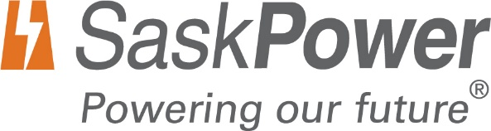
Indigenous Business
Diversity Declaration Form

The following information is being requested on behalf of SaskPower in support of our Supplier Diversity Program. Your participation in reporting this information is important for fostering relationships among all members of the business community. This program is designed to increase the inclusion of Indigenous businesses in SaskPower’s sourcing process.
Your information will be shared with our purchasing groups and other stakeholders involved in sourcing opportunities.
Please return this completed registration form to indigenousprocurement@saskpower.com
BUSINESS INFORMATION (All fields required)

Business Legal Name

Address

City/Town

Province

Phone

Email

Website

This is our Head Office address ☐ Yes ☐ No

Head Office Address (if different from above)

City/Town

Province

Phone

Email

Website

DIVERSITY DECLARATION

SaskPower recognizes the value supplier diversity programs bring to our company: stronger relationships with our Saskatchewan supply base, new business opportunities, greater innovation, and a more agile supply chain.

For monitoring and tracking, SaskPower requires diverse businesses to be registered within its electronic procurement database. Registration is open to all Indigenous-owned businesses.

A business includes a sole proprietorship, limited company, co-operative, partnership, or not-for-profit organization. To be considered an Indigenous business, a business must meet the following criteria:

☐ At least 51 percent of the company is owned, managed, and controlled by Indigenous person(s)

“Indigenous Person(s)” means an individual who resides in Saskatchewan who is a status Indian under the Indian Act (Canada), a Métis Person or an Inuit.

If a business is starting a joint venture or consortium, at least 51 percent of the joint venture or consortium must be controlled and owned by a Saskatchewan-based Indigenous business, as defined above.

Does your company have a supplier diversity program? ☐ Yes ☐ No
Does your company have an employee diversity program? ☐ Yes ☐ No

DESCRIPTION OF BUSINESS

Please check the area (s) below that best describe your business:

☐ Manufacturing
☐ Contracting
☐ Distribution
☐ Engineering
☐ Technology
☐ Consulting
☐ Catering
☐ Other: ___________________

Type of business: Choose an item.
Year established/ incorporated:
Years in business: Choose an item.
Number of employees: Choose an item.

Number of Permanent Employees: Choose an item.

GST Registration Number: ___________________

ISNetworld Company ID #: ___________________ (For High Risk Work)

ISNetworld Registration Name: ___________________ (For High Risk Work)

Type of goods or services supplied:

CONTACT INFORMATION

Contact #1

First Name

Last Name

Position

Address

City/Town

Province

Office #

Mobile #

Email

CONSENT TO SHARING INFORMATION

I hereby consent to and authorize SaskPower to share my business name, my business diversity status, the name and contact information of my business contact and my business address with the public for the purposes of identifying participants in future procurements and engagement events.

☐ Yes ☐ No

____________________________________________ ________________________________________

Signature of Business Representative Date

